2) DC MOTOR DRIVE

1. Armature curent, speed and torque of the current stand-still to steady-state graphs

Figure 7 shows armature current, speed and torque of the motor from stand-still (zero speed) to steady-state vs time.

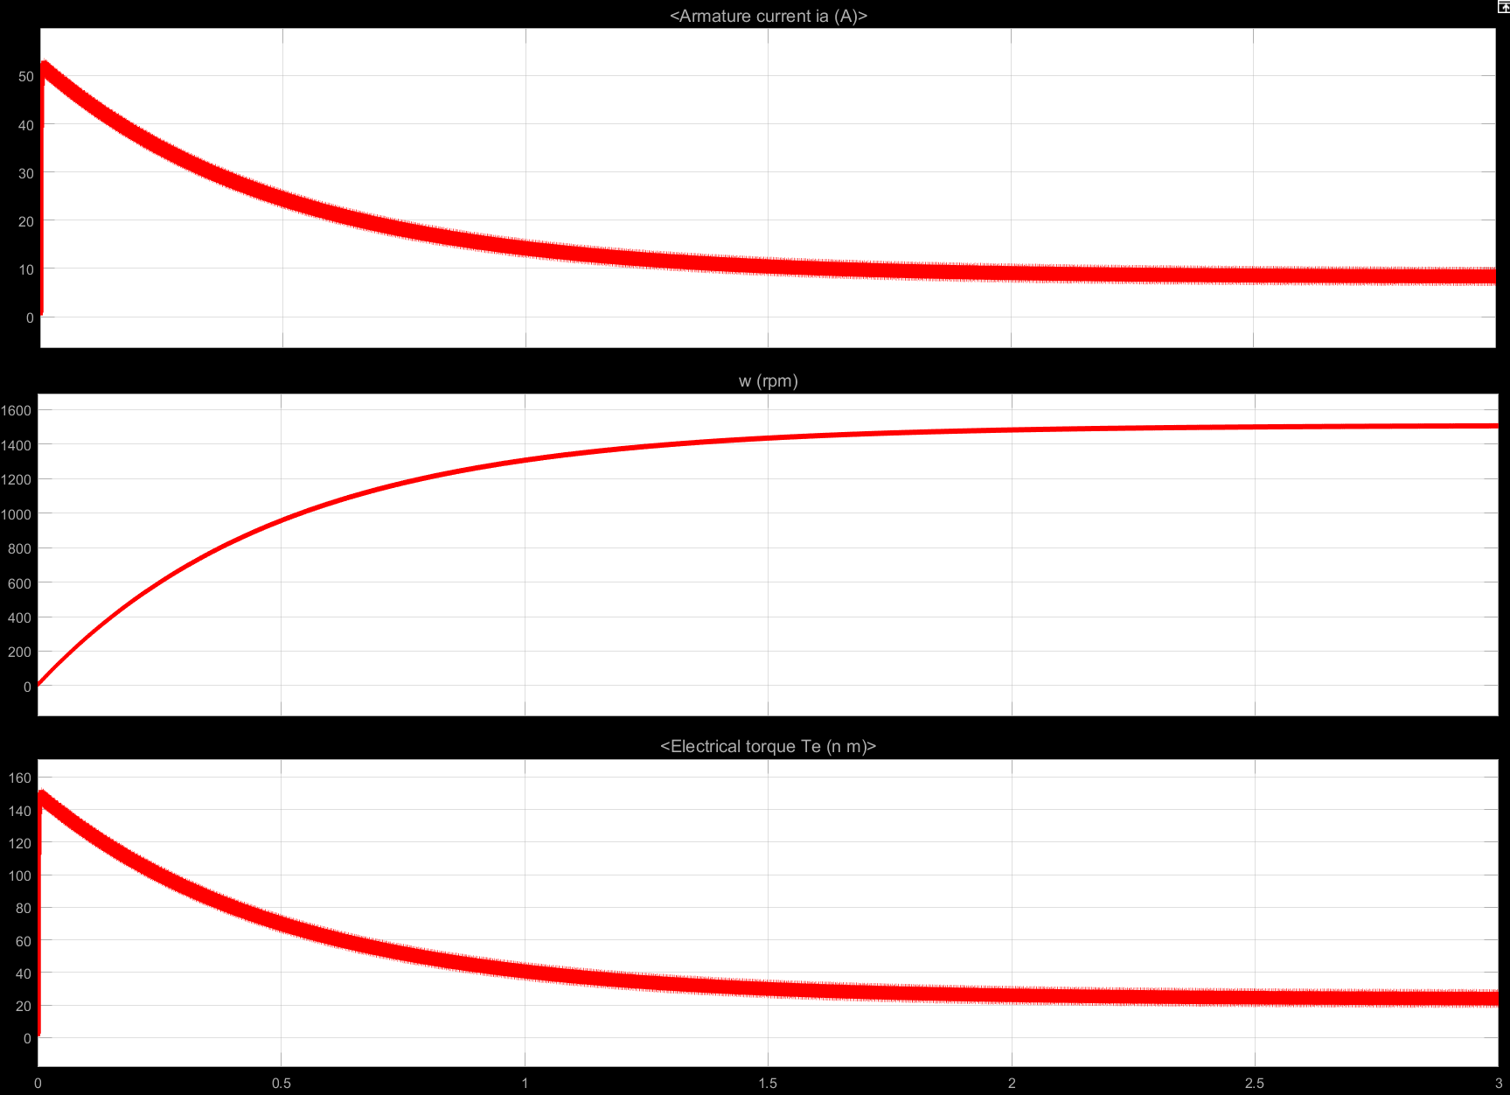

Şekil 1 Armature current, speed and torque of the motor from stand-still (zero speed) to steady-state

1. Characteristics of torque ripple and THD of line current

Figure 8 shows the electrical torque in close up and the statistics of it.

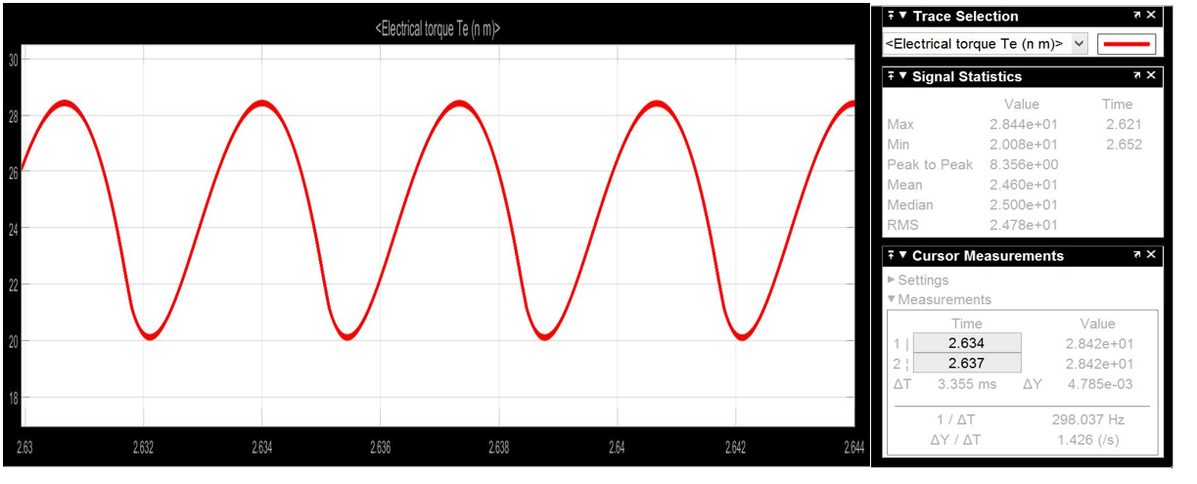

Şekil 2 Electrical torque and its statistics

As can be seen from Figure 8, the output electrical torque frequency is 300 Hz. It is 6 times larger than the grid frequency which is 60 Hz. This is expected since in each cycle there are 3 positive and 3 negative peaks of 3 different phases. Since the voltage is line-to-line, the frequency becomes 6 times larger than the grid frequency at torque ripple.

Figure 9 shows the THD of line current.

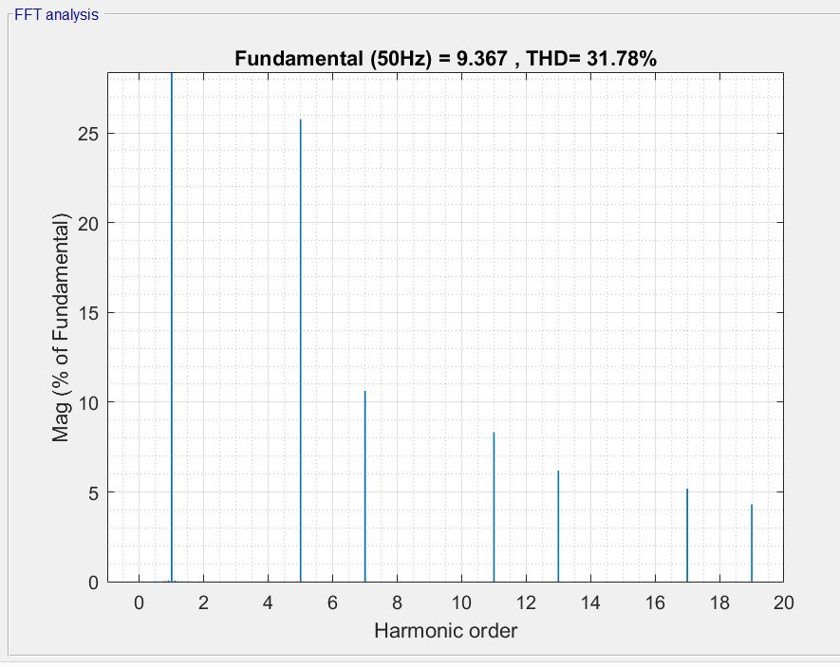

Şekil 3 THD of line current

1. ????????????????
2. Overall Efficiency and Losses

At the steady state, because of the losses during the transmission of electrical power to mechanical power, it is known that there will occur some losses. These losses are because of

* Source side losses
* Diodes losses
* Motor losses

The electrical power will be converted to mechanical power, apart from these losses. Table 1 shows the losses and power flow values.

Table 1: Power flow and losses

|  |  |  |  |  |  |
| --- | --- | --- | --- | --- | --- |
| Input Electrical Power | Source Loss | Diodes Loss | Electrical output power | Motor Loss | Mechanical Output |
| 4586 W | 13,18 W | 27,82 W | 4545 W | 737 W | 3808 W |

By using this simulated results, the efficiencies are calculated as can be seen from Table 2.

Table 2: Efficiencies

|  |  |
| --- | --- |
| Efficiency Motor(%) | Efficiency Total (%) |
| 83,78437844 | 83,0353249 |

The percentage shares of losses can be seen in Table 3 and Figure 4.

Table 3: Percentage shares of losses

|  |  |  |
| --- | --- | --- |
| Source Loss | Diodes Loss | Motor Loss |
| 1,69% | 3,58% | 94,73% |

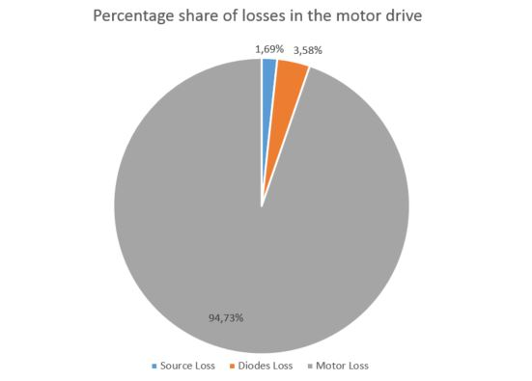

Şekil 4 Percentage share of losses in the motor drive